
PROJECT REPORT
Bank churning

Lina Mahouachi | Farah Haddad | Mariam Maddouri
Supervisor: Prof. Lassad Moubarki

Academic Year 2025-2026
Table Of Content

1.Introduction 4
1.1 Background and Business Context 4
1.2 Problem Statement 4
1.3 Motivation 5
1.4 Objectives 5
1.5 Glossary 5
2. Related Work & Literature Review 6
2.1 Prior Work on This Problem 6
2.1.1 Academic Papers 6
2.2 Relevant Techniques & Methods 6
2.3 Gaps & Contributions 7
3. Data Description & Feature Presentation 8
3.1 Data Sources 8
3.2 Dataset Overview 8
3.3 Feature Description 9
3.4 Target Variable 9
4. Data Preprocessing & Cleaning 10
4.1 Data Quality Assessment 10
4.2 Fixing column names 11
4.3 Duplicate Handling 11
4.3 Drop Unnecessary Columns 11
4.3 Standardize text 11
4.4 Fix Data Types 12
4.5 Encode categorical variables 12
4.6 Feature Engineering 12
4.7 Outlier Detection 13
4.8 Data validation 13
5. Exploratory Data Analysis 13
5.1 Target Distribution 13
5.3 Key Insights & Hypotheses 14
5.5 Geography & Number of Products 16
5.6 Activity Status & Credit Card Effect 16
5.7 Correlation Heatmap 17
5.8 Key Insights & Summary 18
6. Modeling 18
6.1 Data Preparation 18
6.1.1 Define Features & Target 18
6.1.2 Splitting the data 18
6.1.3 Scaling the data 19
6.2 Handling Class Imbalance — SMOTE 19
6.3 Baseline Model 19
6.2 KNN 20
6.2.1 Hyperparameter Tuning 20
6.2.2 KNN results 21
6.3 Logistic Regression 21
6.2.1 Hyperparameter Tuning 21
6.2.2 LR results 22
6.4 Random forest 22
6.5 Model comparison 24
6.5.3 overfitting check 25
7. Discussion 27
7.1 Interpretation of Results 27
7.2 Limitations 27
8. Conclusion & Future Work 28
8.1 Summary 28
8.2 Business Recommendations 28
8.3 Future Work 28

Introduction

1.1 Background and Business Context
Customer churn is a critical issue in the banking sector. It occurs when customers decide to stop using a bank’s services and move to competitors. Retaining existing customers is generally more cost-effective than acquiring new ones, making churn prediction an important business problem.
Banks collect large amounts of customer data, which can be analyzed to identify patterns and behaviors associated with churn. Machine learning techniques provide powerful tools to leverage this data and make accurate predictions.

1.2 Problem Statement
In the modern banking sector, retaining customers is a major challenge due to increasing competition and ease of switching between financial institutions, but the underlying patterns and drivers behind customer churn are not immediately obvious and require analytical and predictive modeling techniques to uncover.
The problem addressed in this project is to analyze features and build machine learning models that can accurately predict customer churn. This involves identifying which factors such as low account activity, high balance, geographic location, or customer age contribute most significantly to churn behavior.
The main problem: To predict whether a customer will leave the bank (churn) based on their personal and account-related information. This is a binary classification problem.

1.3 Motivation
Customer churn has a direct impact on a bank’s profitability. By predicting which customers are likely to leave, banks can:
- Take preventive actions (offers, better service)
- Improve customer satisfaction
- Increase retention rates
- Reduce revenue loss

This project demonstrates how data-driven approaches can support strategic business decisions.

1.4 Objectives
- Analyze and understand the dataset and its key features
- Perform data cleaning and preprocessing to ensure data quality
- Explore relationships between variables and customer churn
- Develop and apply at least two machine learning models
- Compare model performance using appropriate evaluation metrics
- Identify the most important factors influencing customer churn

1.5 Glossary
Churn (Customer Churn) | The phenomenon where a customer stops using a bank’s services or closes their account. In this project, churn is the target variable we aim to predict.
Feature (Variable) | An individual measurable property of the data (e.g., Age, Balance, Credit Score). These are used as inputs for the model.
Target Variable | The variable the model is trying to predict. In this case, it is Churn (Exited: 0 = No, 1 = Yes).
Data Preprocessing | The process of cleaning and preparing raw data before modeling
Overfitting | When a model learns the training data too well, including noise, and performs poorly on new unseen data.
Data Leakage | When information from outside the training dataset is used to create the model, leading to overly optimistic performance.
Hyperparameters | Settings of a model that are defined before training (e.g., number of trees in Random Forest).

2. Related Work & Literature Review

2.1 Prior Work on This Problem
Customer churn prediction in the banking sector has been extensively studied in the machine learning literature. Seminal works by Bhattacharya (1994) and more recent studies have framed churn as a binary classification problem. Studies have shown that ensemble methods such as Random Forests and Gradient Boosting consistently outperform simpler classifiers on tabular banking data. The Kaggle bank churn dataset (a widely used benchmark) has been tackled using a range of approaches from decision trees to deep neural networks.

2.1.1 Academic Papers
Xie et al. (2009)— "Customer churn prediction using improved balanced random forests" : demonstrated that ensemble methods outperform single classifiers for imbalanced churn datasets.
Verbeke et al. (2012) —"New insights into churn prediction in the telecommunication sector" : highlighted the importance of AUC over accuracy in imbalanced classification.
Coussement & Van den Poel (2008)— demonstrated that SVM and logistic regression are strong baselines for churn, especially with proper feature engineering.

2.2 Relevant Techniques & Methods
Early Approaches (2000–2010): Logistic regression was the dominant method due to its interpretability and simplicity. Neslin et al. (2006) found it competitive with complex models across banking and other industries.
Ensemble Methods (2010–2018): Random Forests and Gradient Boosting emerged as superior performers. Verbeke, Martens, & Baesens (2011) showed Random Forest consistently outperformed logistic regression in AUC, while XGBoost (Chen & Guestrin, 2016) became industry standard for handling missing data and preventing overfitting.
Deep Learning (2018–present): Neural networks have been explored for sequential customer journey data. However, for tabular banking data like this dataset, ensemble tree-based methods remain state-of-the-art (Grmanová & Janáček, 2021).

2.3 Gaps & Contributions
While many studies focus on pure prediction accuracy, this project also emphasizes interpretability of results: identifying which features drive churn, and addresses data quality issues present in the original messy dataset (duplicates, missing values,error data types and inconsistent encoding). This end-to-end pipeline from raw messy data to evaluated models constitutes the primary contribution.

3. Data Description & Feature Presentation

3.1 Data Sources
The dataset used in this project is a synthetic banking dataset derived from a publicly available Kaggle competition on bank customer churn. It contains records for 100000 customers and includes demographic, behavioral, and financial attributes.

3.2 Dataset Overview
After initial loading, the dataset presents the following characteristics:
- Shape: 11,000 rows × 13 columns
- Mix of int64 (8 columns) , object (3 columns) and float 64 ( 2 columns) data types

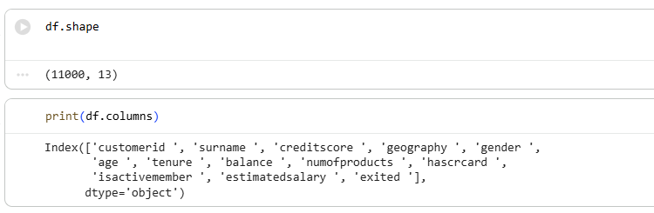
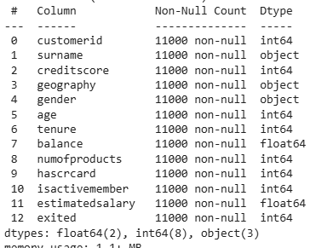

3.3 Feature Description
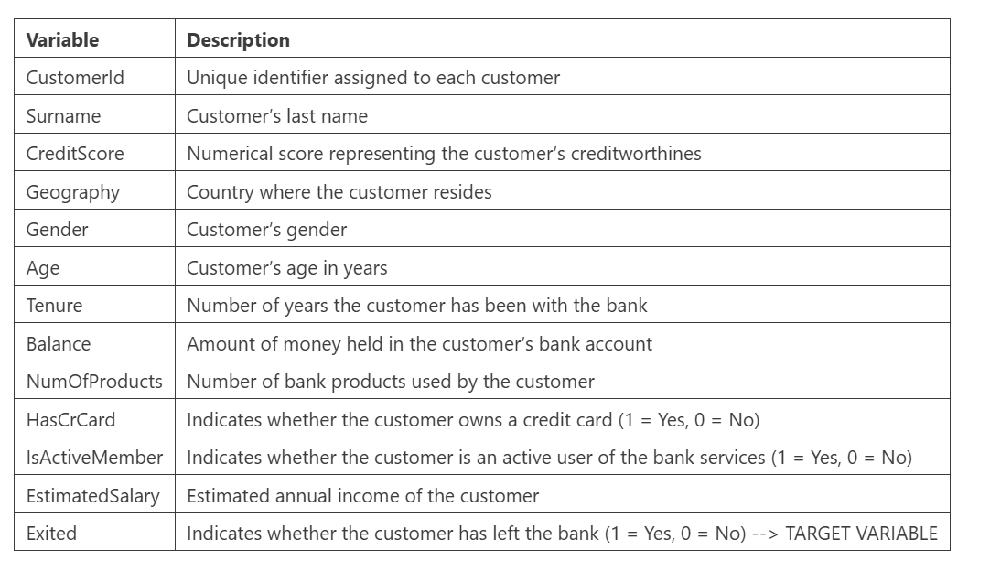

3.4 Target Variable
The target variable in this project is Exited, which indicates whether a customer has churned (left the bank) or not.
- Exited = 1 → The customer has left the bank (churned)
- Exited = 0 → The customer remains with the bank
This makes the problem a binary classification task, where the objective is to predict the probability of a customer leaving the bank based on their characteristics.

4. Data Preprocessing & Cleaning

4.1 Data Quality Assessment

An initial data quality audit revealed the following issues in the raw dataset:
- 1000 duplicate rows
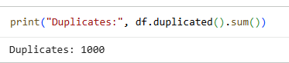

- 0~1,000 missing values per column (0% missingness), Data considered clean

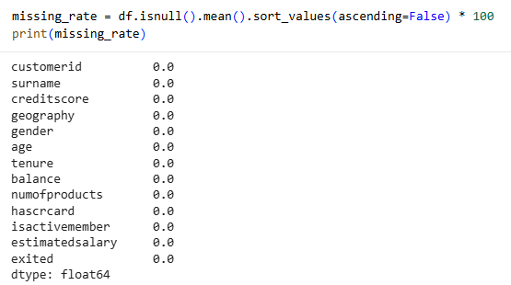

- Inconsistent gender encoding: 'F'/'M' instead of 'Female'/'Male'
- Unnecessary Columns for the future of this project

4.2 Fixing column names
Column names were standardized by removing extra spaces, converting all characters to lowercase, and replacing spaces with underscores. This ensures consistency and facilitates easier data manipulation.

4.3 Duplicate Handling
Duplicate records were identified and removed to prevent bias and redundancy in the dataset. This step improves data integrity and ensures more reliable model training.

4.3 Drop Unnecessary Columns
CustomerId and Surname carry no predictive signal and were dropped to reduce noise and avoid inadvertent data leakage.
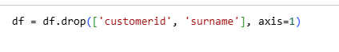

4.3 Standardize text
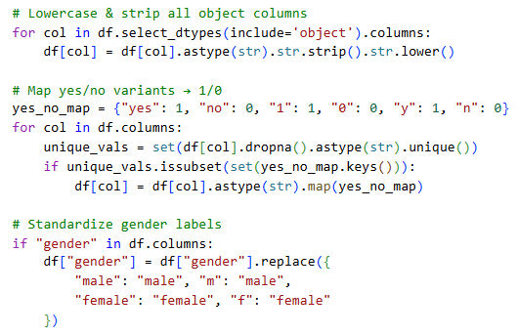

4.4 Fix Data Types
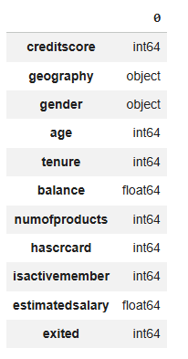

All columns were transformed to numeric types where possible using pd.to_numeric(), keeping non-numeric columns (geography, gender) as object types for subsequent encoding. This resolved any inconsistencies arising from mixed text/numeric representation.

4.5 Encode categorical variables
Categorical variables were transformed into numerical representations using encoding techniques such as label encoding and one-hot encoding. This step is necessary for machine learning models such as KNN, Logistic Regression and ANN.

4.6 Feature Engineering
Two new features were engineered to capture additional signal:
- balance_salary_ratio: The ratio of account balance to estimated salary, capturing relative wealth positioning.
- zero_balance: A binary flag for customers with zero account balance, as this behavioral signal may indicate disengagement.

4.7 Outlier Detection
Boxplots were generated for Age and Balance to identify extreme values. Analysis showed:
- Age range: 18–92 years, mean 38.92 : values are plausible for a banking customer base.
- Balance range: 0.0–250,898 EUR, mean 76,486 EUR : the high maximum reflects genuine high-value customers, not data errors.
No outlier removal was performed, as the extreme values represent real customer segments rather than data entry errors.
Final dataset after all cleaning steps: 10,000 rows × 14 columns, zero missing values, all numeric types.
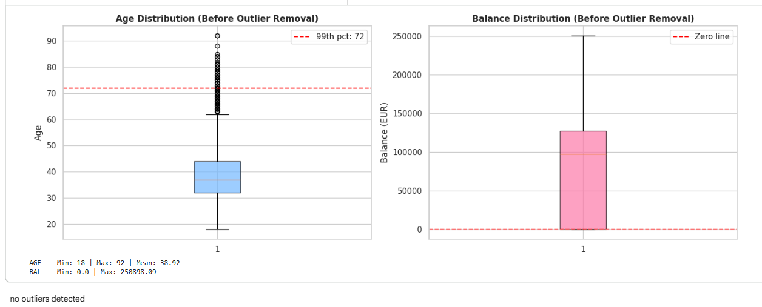

4.8 Data validation
The dataset was validated by checking data types, ensuring no duplicates remained, and verifying that columns such as credit_score, balance, and estimated_salary contained consistent numerical values. Summary statistics were reviewed to confirm correctness.

5. Exploratory Data Analysis

5.1 Target Distribution
The target variable distribution was visualized using both a count bar chart and a proportion pie chart.
- Retained (Exited = 0): 7,963 customers (79.6%)
- Churned (Exited = 1): 2,037 customers (20.4%)
The dataset is imbalanced: approximately 20% of customers churned while 80% were retained. A naive classifier that always predicts 'no churn' would achieve ~80% accuracy simply by exploiting this imbalance — making raw accuracy a misleading metric. We prioritize Recall and ROC-AUC for model evaluation, and apply SMOTE during training to mitigate the imbalance.
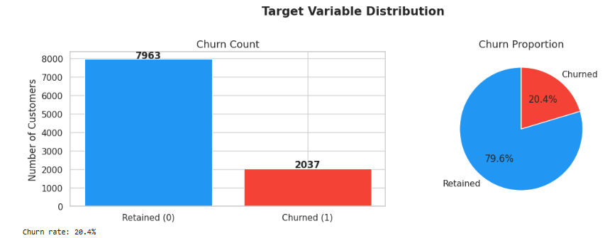

5.3 Key Insights & Hypotheses

Hypothesis 1: Age impacts churn
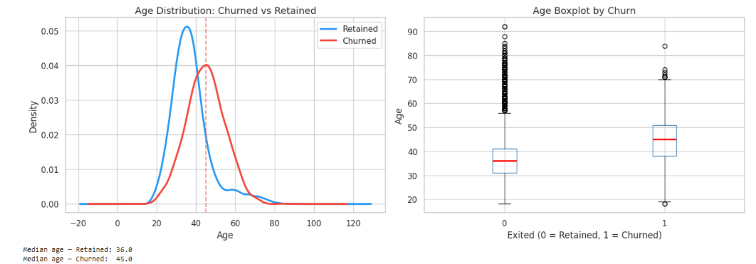

H0: Age does NOT affect churn H1: Age affects churn
Result: Reject H₀. The age distributions differ clearly between groups. Churned customers are systematically older, with a median age approximately 10 years higher than retained customers (median churned ≈ 45, median retained ≈ 37). The KDE curves show a bimodal churn peak in the 40–55 age range.
Hypothesis 2:
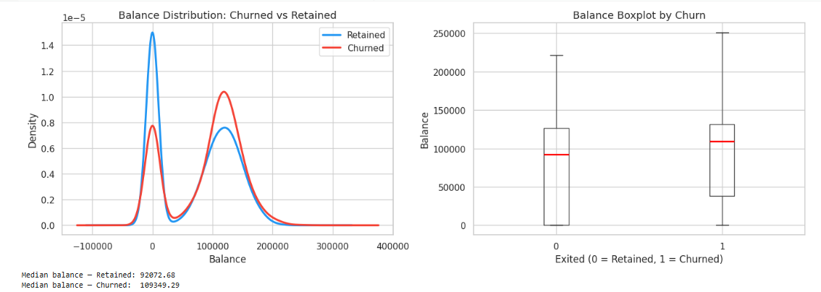

H₀: Balance does NOT affect churn. H₁: Balance affects churn.
Result: Reject H₀. Churned customers tend to have a higher median account balance (median ≈ 109,349 EUR) compared to retained ones (median ≈ 92,073 EUR). This is counter intuitive at first glance. However, this pattern may reflect high-value customers who are dissatisfied with service quality or product offerings and are actively seeking alternatives. Balance alone is insufficient for retention targeting; customer satisfaction data would complement this signal.

Hypothesis 3:
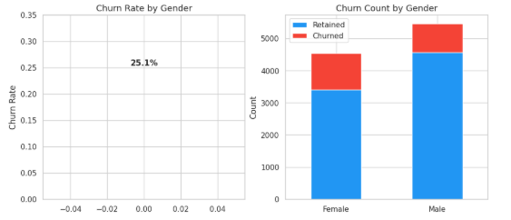
H₀: Gender does NOT affect churn. H₁: Gender affects churn.
Result: Reject H₀. Female customers exhibit a noticeably higher churn rate (25.1%) than male customers, despite both groups being roughly equally represented in the dataset. This suggests gender is a relevant predictor. The bank should investigate whether product offerings or service experiences differ between genders, as targeted retention campaigns could be more effective with gender-specific insights.

5.5 Geography & Number of Products
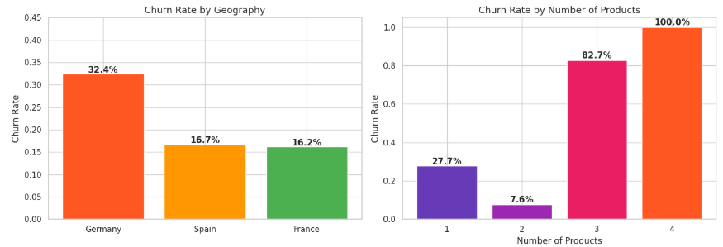
Churn rates were analyzed across geographic markets and number of products held.
Geography: Germany stands out with a dramatically higher churn rate (32.4%) compared to France (16.2%) and Spain (16.7%). This geographic disparity suggests structural differences in customer satisfaction, product fit, or competitive pressure across markets. Separate retention strategies per country may be warranted.
Number of Products: A striking non-linear pattern was observed. Customers with 1 product: 27.7% churn rate; 2 products: 7.6%; 3 products: 82.7%; 4 products: 100%. This likely reflects a reverse causality signal ,disengaging customers may have been sold additional products they do not use, or the bank's product mix is not meeting needs at higher product counts. This feature is highly important for tree-based models.

5.6 Activity Status & Credit Card Effect
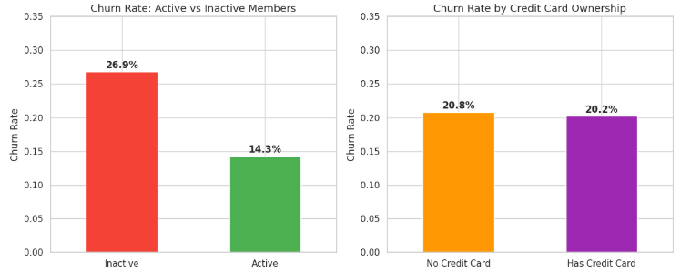
Activity Status: Inactive members churn at nearly double the rate of active ones (26.9% vs 14.3%). Engagement is a strong protective factor : customers who actively use the bank's services have stronger behavioral ties that reduce switching costs. This suggests the bank should invest in re-engagement campaigns for passive customers.
Credit Card Ownership: Shows a minimal difference in churn rates (no credit card: 20.8%; has credit card: 20.2%), suggesting it is not a meaningful discriminator on its own and will contribute little predictive power in the models.

5.7 Correlation Heatmap
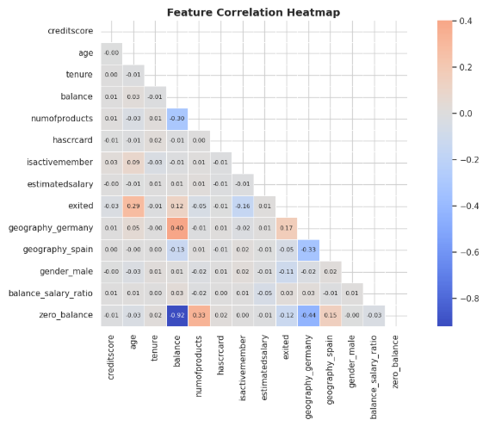
A lower-triangle correlation heatmap was generated for all numeric features.
- Age has the strongest positive correlation with churn (≈0.29).
- Activity status shows a notable negative correlation (≈-0.16), reinforcing the EDA finding that active engagement is protective against churn.
- Number of products carries some correlation signal.
- No feature pairs are highly collinear (>0.8), reducing multicollinearity concerns for Logistic Regression.

5.8 Key Insights & Summary
- The dataset is imbalanced (~20% churn rate), requiring careful metric selection.
- Age is the strongest individual predictor: older customers (40–55) churn significantly more.
- German customers churn at nearly double the rate of French and Spanish customers.
- Customers with 3–4 products churn at extremely high rates — a non-linear signal.
- Inactive members are far more likely to churn; engagement is a key retention lever.
- Balance is counter intuitively higher for churners, suggesting dissatisfied high-value customers.

6. Modeling

6.1 Data Preparation

6.1.1 Define Features & Target
The target variable (exited) was separated from the feature matrix X. All 13 remaining columns were used as features after dropping the target.
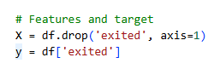

6.1.2 Splitting the data
The dataset was divided into training and testing sets using an 80/20 split. Stratification was applied to preserve the original class distribution of the target variable, ensuring reliable evaluation of model performance
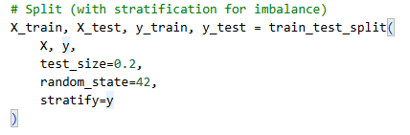

6.1.3 Scaling the data
Feature scaling was applied using StandardScaler to normalize numerical variables. This step is essential for models such as K-Nearest Neighbors and Logistic Regression, which are sensitive to differences in feature magnitudes. The scaler was fit on the training set only and applied to both train and test to prevent data leakage.
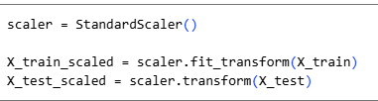

6.2 Handling Class Imbalance — SMOTE
SMOTE (Synthetic Minority Over-sampling Technique) was applied to the training set to address the class imbalance (79.6% retained vs. 20.4% churned). SMOTE generates synthetic samples for the minority class by interpolating between existing minority instances, creating new plausible data points rather than simply duplicating.
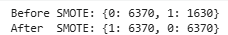
SMOTE was applied only to the training set . The test set remained untouched to provide an unbiased evaluation of real-world performance.

6.3 Baseline Model
A Dummy Classifier using the 'most_frequent' strategy was established as a performance floor. This classifier always predicts the majority class (Retained) regardless of input features.
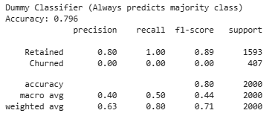
The dummy classifier achieves ~80% accuracy purely by exploiting the class imbalance. Any model that does not significantly exceed this baseline is simply learning the class distribution rather than meaningful patterns. Its Recall of 0.000 for churners confirms it is useless for the actual business problem.
KNN model will particularly suffer with this.

6.2 KNN

6.2.1 Hyperparameter Tuning

The KNN model was optimized using GridSearchCV with 5-fold cross-validation, optimizing for ROC-AUC. The following parameter grid was explored:
n_neighbors: [3, 5, 7, 11, 15, 21]
weights: ['uniform', 'distance']
metric: ['euclidean', 'manhattan']
Best parameters: metric='manhattan', n_neighbors=7, weights='distance'
Best CV ROC-AUC: 0.9515

6.2.2 KNN results
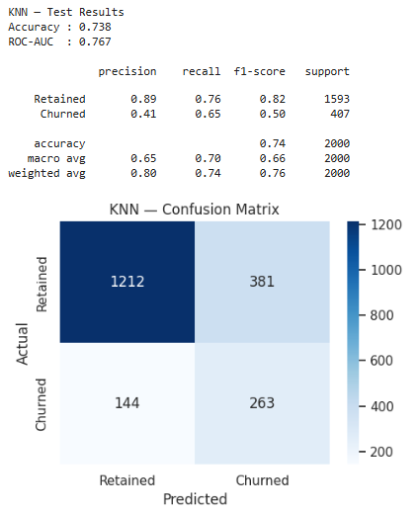
KNN shows a notable gap between cross-validation AUC (0.9515) and test AUC (0.767), and a large overfitting gap (train accuracy 1.000 vs test 0.738 = gap of 0.262). This indicates the model memorized the SMOTE-augmented training data and does not generalize well. Its high CV score is inflated by proximity to synthetic neighbors.
This suggests that alternative models less sensitive to local data density, such as tree-based methods or regularized models, may provide more robust performance on imbalanced datasets.

6.3 Logistic Regression

6.2.1 Hyperparameter Tuning
Logistic Regression was tuned using GridSearchCV
Best parameters: C=1, penalty='l2', solver='lbfgs'
Best CV ROC-AUC: 0.7772

6.2.2 LR results
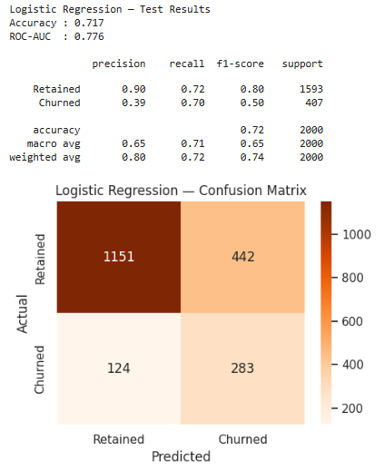

Logistic Regression achieves the best Recall among all models (0.70), meaning it identifies 70% of actual churners. Its minimal overfitting gap (-0.004) makes it the most generalizable model. However, its low Precision (0.39) means it generates many false alarms — 61% of its churn predictions are incorrect.

6.4 Random forest

6.4.1 Hyperparameters tuning

Random Forest was tuned using GridSearchCV with the following parameter grid:
n_estimators: [100, 200, 300]
max_depth: [5, 10, 20, None]
min_samples_split: [2, 5, 10]
Best parameters: max_depth=None, min_samples_split=2, n_estimators=300
Best CV ROC-AUC: 0.9647

6.4.2 RF results

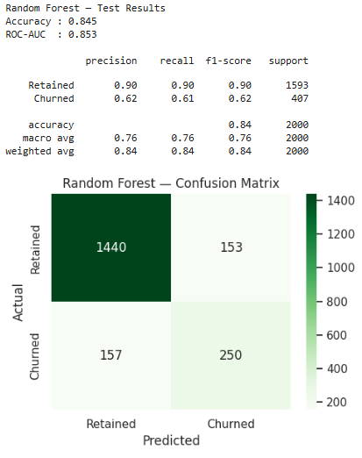
Random Forest is the best-performing model across all key metrics. It achieves the highest accuracy (84.5%), highest ROC-AUC (0.853), and best F1-Score for churners (0.617), demonstrating its ability to capture the non-linear churn signals identified in EDA (particularly the product count and age effects).

6.5 Model comparison
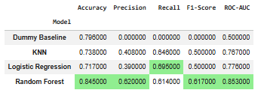

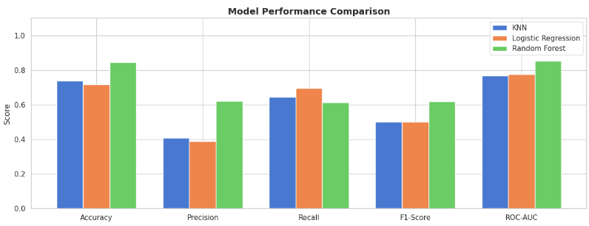
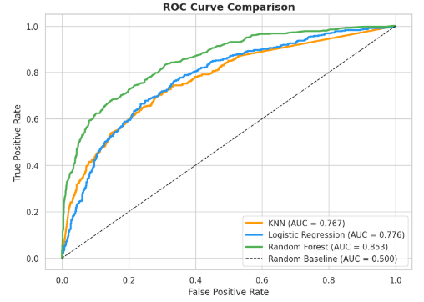

ROC curves were plotted for all three models against the random baseline (AUC = 0.500).
Random Forest: AUC = 0.853 (best)
Logistic Regression: AUC = 0.776
KNN: AUC = 0.767
A higher AUC means the model is better at ranking actual churners above non-churners at any probability threshold. All three models significantly outperform the random baseline, confirming they have learned meaningful churn signals. The Random Forest curve rises steeply in the low false-positive-rate region, indicating it is especially reliable for high-precision targeted interventions.

6.5.3 overfitting check
KNN shows severe overfitting (gap of 0.262): it memorized the SMOTE training data. Logistic Regression shows virtually no overfitting (gap of -0.004), consistent with its L2 regularization. Random Forest shows a moderate gap (0.155), typical of deep trees, but this is controlled by GridSearchCV's exploration of max_depth constraints.
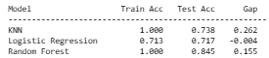

7.4 Cross-Validation (Stability Check)
Cross-validation confirms model stability across different data folds. Random Forest achieves the highest CV AUC (0.965) with a moderate standard deviation (0.020). Logistic Regression is most stable (std 0.009). KNN's high CV score (0.952) is inflated by proximity to SMOTE neighbors and does not reflect true generalization, as evidenced by the large overfitting gap.
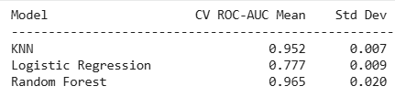

7.5 Feature Importance — Random Forest
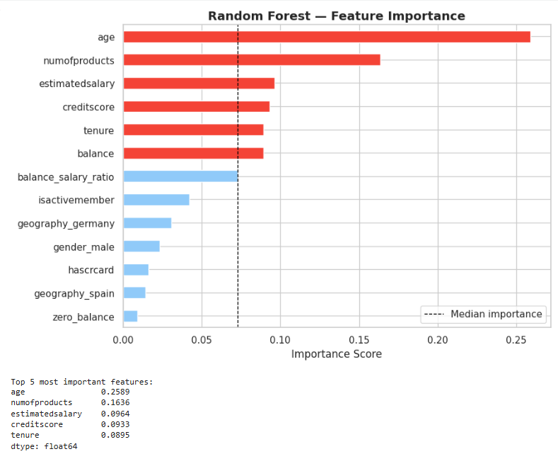

The Random Forest( our best model so far) feature importance analysis reveals which variables contributed most to splitting decisions. Age dominates with an importance score of 0.2589, more than 50% higher than the second most important feature. The top 5 features (age, numofproducts, estimatedsalary, creditscore, tenure) account for the majority of predictive signal, consistent with EDA findings.
Features like hascrcard, geography_spain, and zero_balance contribute minimally. This ranking can guide feature selection in future iterations: focusing on the top 5–7 features may yield a simpler model with comparable performance, reducing overfitting risk and improving interpretability for business stakeholders.

7. Discussion

7.1 Interpretation of Results

The results confirm that bank customer churn is a predictable phenomenon when the right features are identified and appropriate models are applied. The Random Forest model's superior performance validates two key observations from EDA: (1) churn patterns are non-linear (particularly the product count effect), and (2) the combination of demographic and behavioral features provides strong discriminative power.
The counter intuitive finding that churners have higher account balances than retained customers is an important business insight. It challenges the assumption that only low-value customers leave, and suggests the bank may be losing high-value clients due to service quality or competitive offers rather than financial constraints.
The dramatic geographic disparity (Germany 32.4% vs. France/Spain ~16%) strongly suggests market-specific factors at play, possibly different competitive landscapes, product-market fit, or service quality issues. This warrants country-specific retention strategies rather than a one-size-fits-all approach.

7.2 Limitations

- The dataset is synthetic: it simulates real banking data but may not capture all complexities of actual customer behavior.
- No temporal features: the dataset provides a snapshot in time without transaction history or behavioral trends over time.
- SMOTE on tabular data: while effective, synthetic oversampling can introduce noise if the minority class distribution is complex.
- KNN's high cross-validation score is misleading due to proximity to SMOTE neighbors; the true generalization gap is large.
- Absence of customer satisfaction scores and product usage frequency limits the model's ability to capture service-related churn.

8. Conclusion & Future Work

8.1 Summary
This project built and evaluated a complete machine learning pipeline for predicting bank customer churn. Starting from a deliberately messy dataset of 11,000 records, we performed systematic data cleaning (removing 1,000 duplicates, standardizing encodings, engineering 2 new features) and conducted thorough exploratory analysis to formulate and test three churn hypotheses.
Three models were developed and compared: K-Nearest Neighbors, Logistic Regression, and Random Forest. All three significantly outperformed the dummy baseline. The Random Forest model emerged as the best overall performer with ROC-AUC of 0.853 and F1-Score of 0.617 for churners, while Logistic Regression offered the best Recall (0.70) and near-zero overfitting.

8.2 Business Recommendations
- Deploy the Random Forest model as the primary churn predictor.
- Set the classification threshold below 0.5 (e.g., 0.35) to prioritize Recall , catching more churners at the cost of some false alarms is typically more cost-effective for retention campaigns.
- Priority retention targets: German customers, customers with 3–4 products, inactive members aged 40–55 with high balances.
- Investigate the German market specifically: the 2x higher churn rate likely reflects addressable structural issues (competitive pressure, product-market fit, or service quality gaps).
- Launch re-engagement campaigns for inactive members before they churn, since inactivity is a strong early warning signal.

8.3 Future Work
- Experiment with XGBoost / LightGBM for potentially higher AUC, as gradient boosting methods are state-of-the-art for tabular classification.
- Add customer satisfaction scores and transaction frequency features if available.
- Build a Precision-Recall curve analysis to select the optimal business threshold based on the actual cost ratio.
- Deploy the model with SHAP values for individual-level explainability, enabling personalized retention offers.
- Explore temporal modeling with customer transaction history to capture behavioral drift over time.

